**Lab5 Report**

Content

1.What is a container? 2

1.1 Theory 2

1.2 Process 3

2.What is an image? 5

1.1 Theory 5

1.2 Process 6

3.What is Docker Compose? 7

1.1 Theory 7

1.2 Process 8

4.Publishing and exposing ports 10

1.1 Theory 10

1.2 Process 11

5.Overriding container defaults 12

1.1 Theory 12

1.2 Process 13

1. Run multiple instances of the Postgres database 13

2. Run Postgres container in a controlled network 13

3. Override the default CMD and ENTRYPOINT in Docker Compose 14

6. Persisting container data 15

1.1 Theory 15

1.2 Process 16

7. Sharing local files with containers 17

1.1 Theory 17

1.2 Process 18

1. Run a container 18

2. Use a bind mount 18

8. Multi-container applications 19

1.1 Theory 19

1.2 Process 20

# 1.What is a container?

## 1.1 Theory

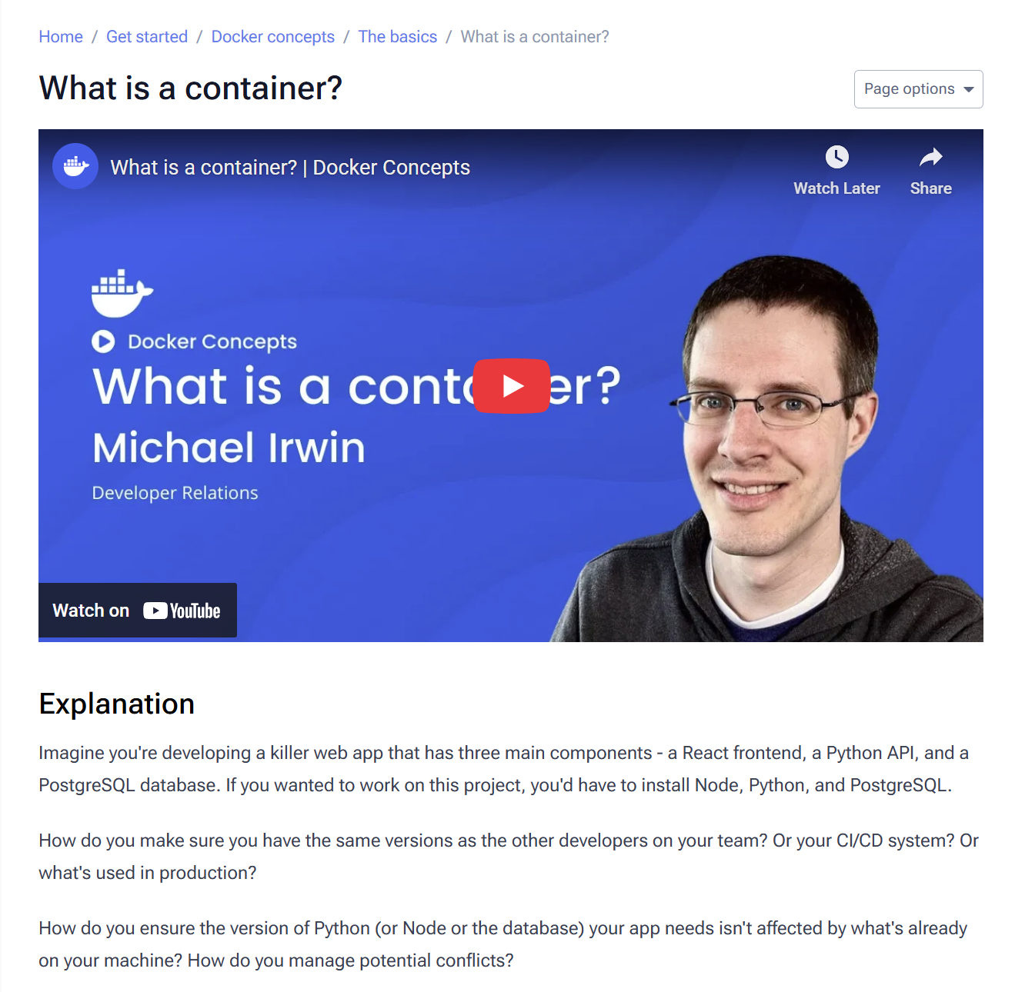

* Problem: Developing multi-component applications (e.g., React, Python API, PostgreSQL) leads to environment inconsistencies, dependency conflicts, and challenges in replicating setups across development, CI/CD, and production.
* Solution: Containers.
* What is a container? An isolated process that packages an application component with all its dependencies.
* Key Benefits:
  + Self-contained: No reliance on pre-installed software on the host machine.
  + Isolated: Enhanced security and minimal interference between components.
  + Portable: Guarantees consistent behavior from local development to the cloud.
* Containers vs. VMs: Containers are more lightweight and efficient than VMs because they are isolated processes sharing the host OS kernel, rather than virtualizing an entire operating system.

## 1.2 Process

Open Docker Desktop and select the Search field on the top navigation bar. Specify welcome-to-docker in the search input and then select the Pull button.

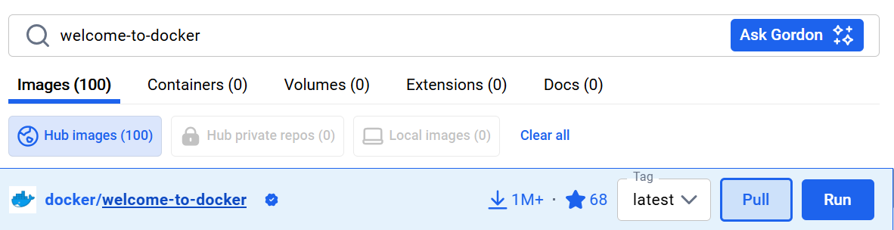

Once the image is successfully pulled, select the Run button. Expand the Optional settings.

In the Container name, specify welcome-to-docker. In the Host port, specify 8080.

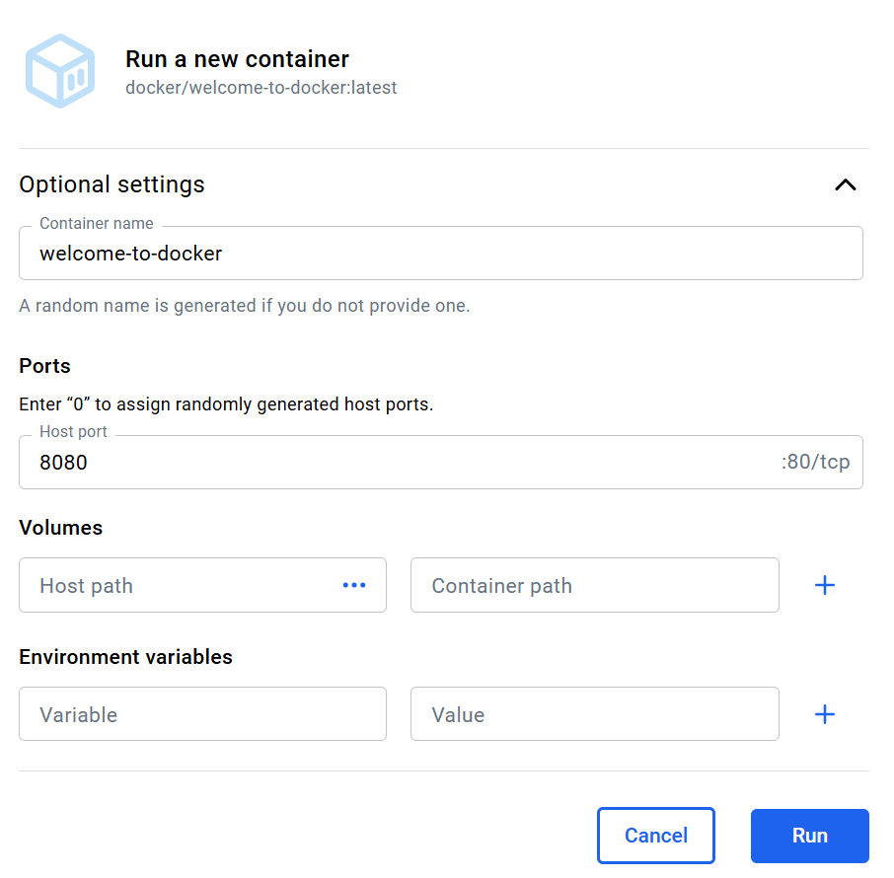

Then, select **Run** to start the new container.

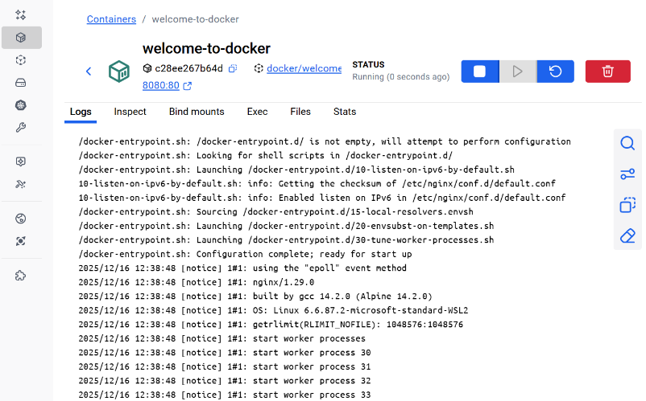

We can view all of our containers by going to the Containers view of the Docker Desktop Dashboard.

This container runs a web server that displays a simple website. When working with more complex projects, we'll run different parts in different containers. For the new container, the frontend is accessible on port 8080. To open the website, select the link in the Port(s) column of our container or visit [http://localhost:8080](http://localhost:8080/) in the browser.

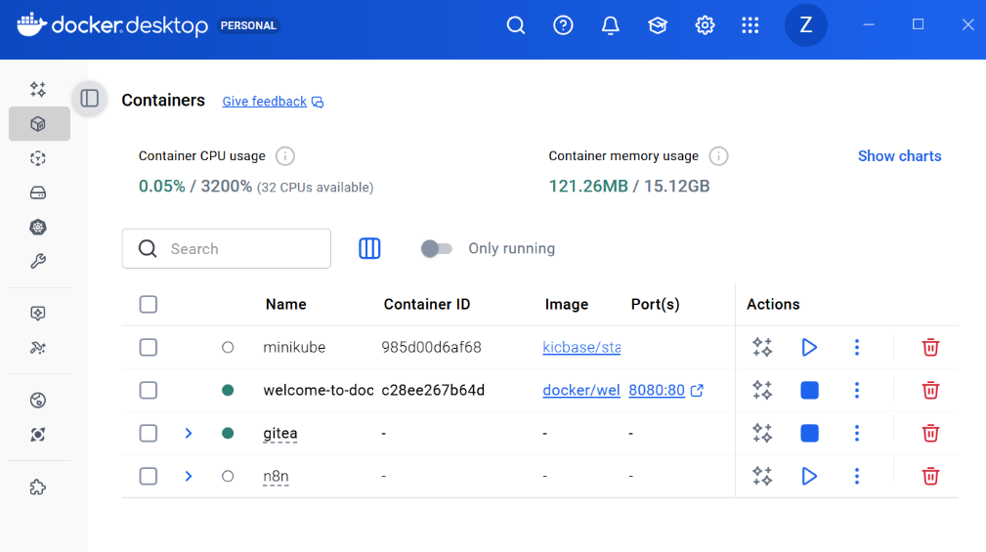

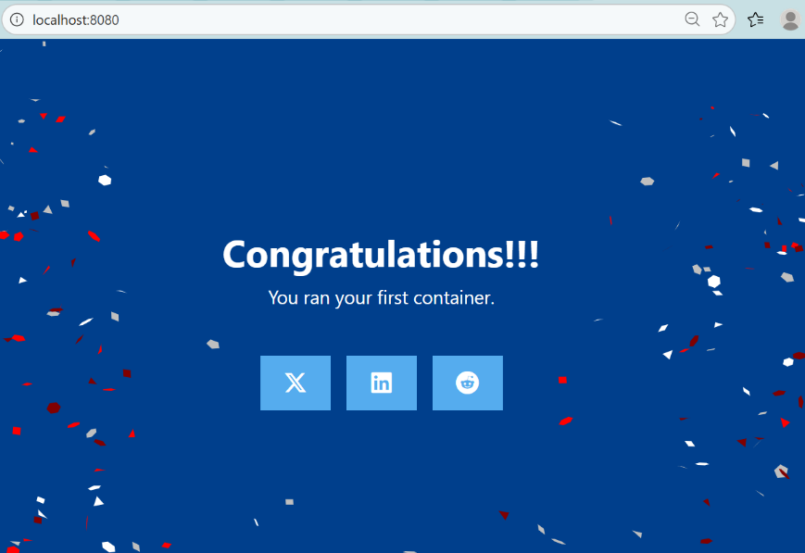

Go to the Containers view in the Docker Desktop Dashboard. Select our new container. Select the Files tab to explore our container's isolated file system.

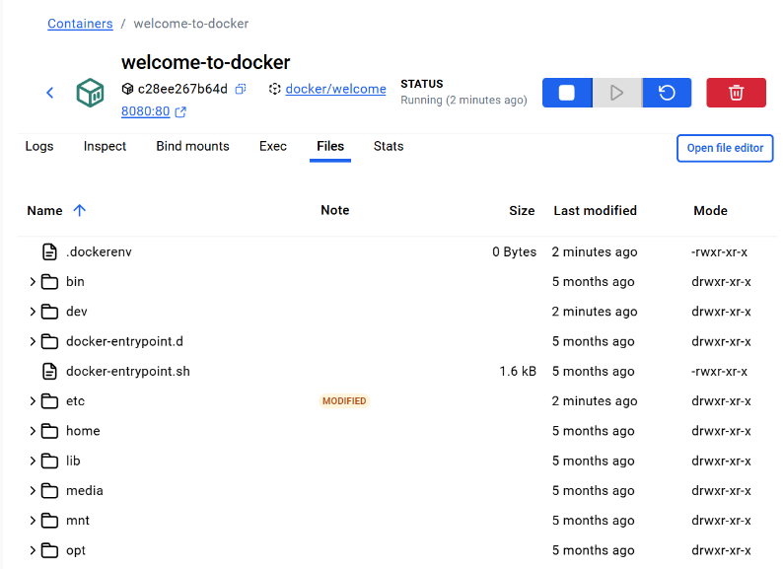

# 2.What is an image?

## 1.1 Theory

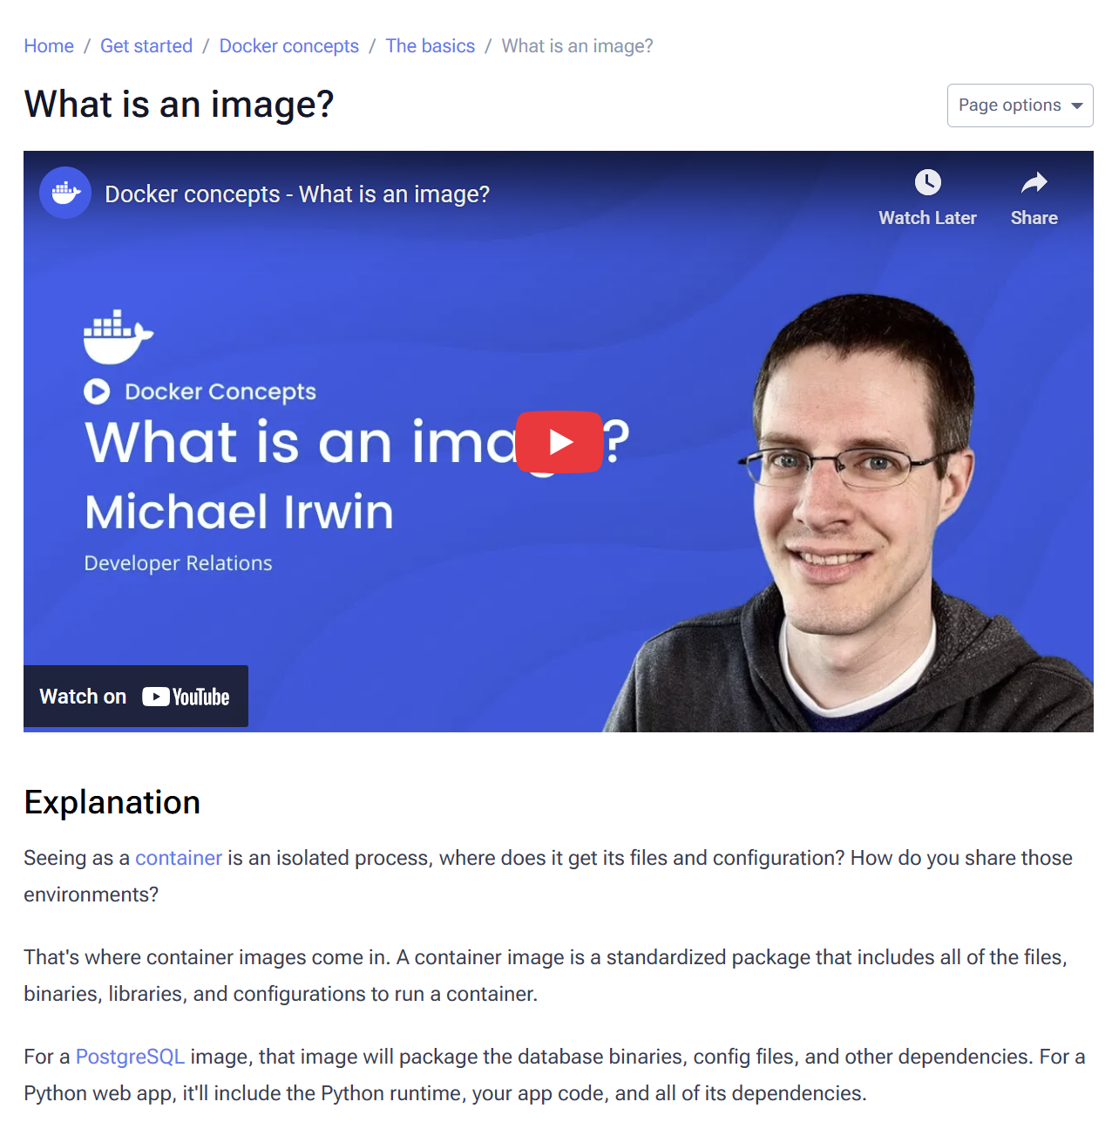

* Core Concept: A container image is a standardized, ready-to-run package that contains everything needed for a container: files, binaries, libraries, and configuration.
* Key Principles of Images:
  + Immutable: Once built, an image cannot be changed. Any updates require creating a new image.
  + Layered: Images are built from multiple read-only layers, where each layer represents a set of filesystem changes (e.g., adding, removing, or modifying files).
* Practical Benefit: This layered and immutable structure allows you to extend existing images (e.g., starting with a base Python image and adding your app code as a new layer), promoting efficiency and reuse.
* Source for Images: Docker Hub is the primary public registry for finding and distributing container images.
* Types of Trusted Content on Docker Hub:
  + Docker Official Images: Curated, secure starting points for most users (e.g., Node.js, Python, Redis).
  + Docker Verified Publishers: High-quality images from verified commercial publishers.
  + Docker-Sponsored Open Source: Images maintained by open-source projects sponsored by Docker.

## 1.2 Process

Open the Docker Desktop Dashboard and select the **Images** view in the left-hand navigation menu. In the **Search** field, enter "welcome-to-docker". Once the search has completed, select the docker/welcome-to-docker image. Select Pull to download the image.

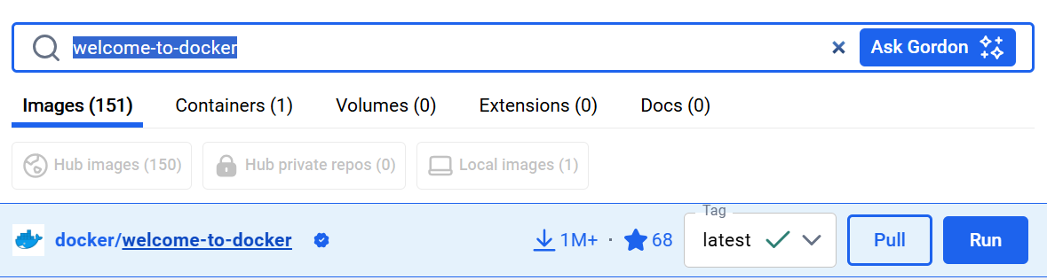

In the Docker Desktop Dashboard, select the Images view.

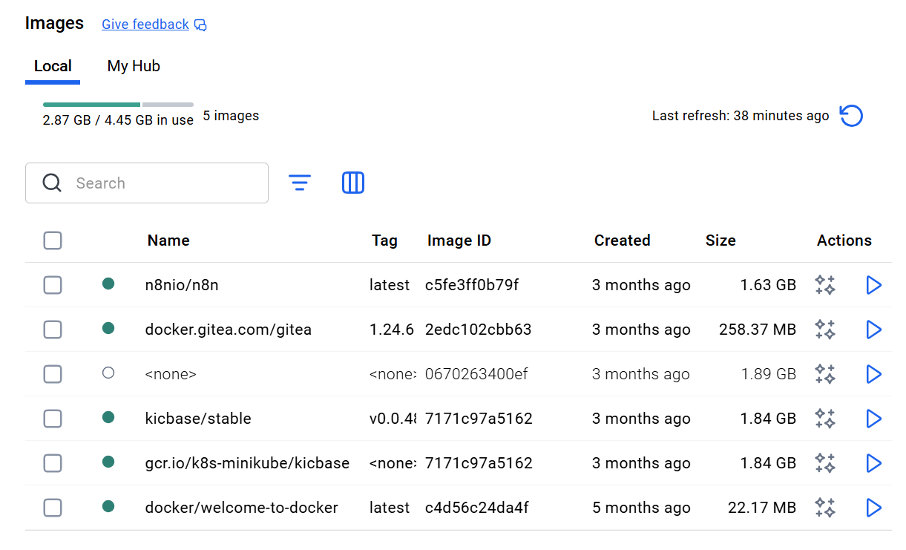

Select the **docker/welcome-to-docker** image to open details about the image.

The image details page presents us with information regarding the layers of the image, the packages and libraries installed in the image, and any discovered vulnerabilities.

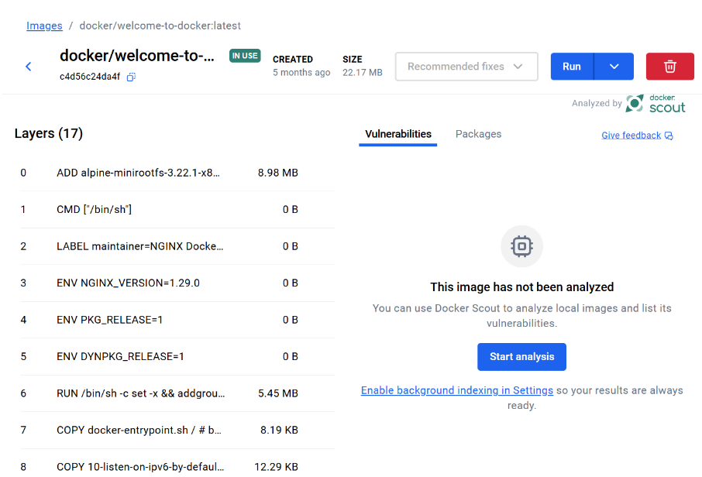

# 3.What is Docker Compose?

## 1.1 Theory

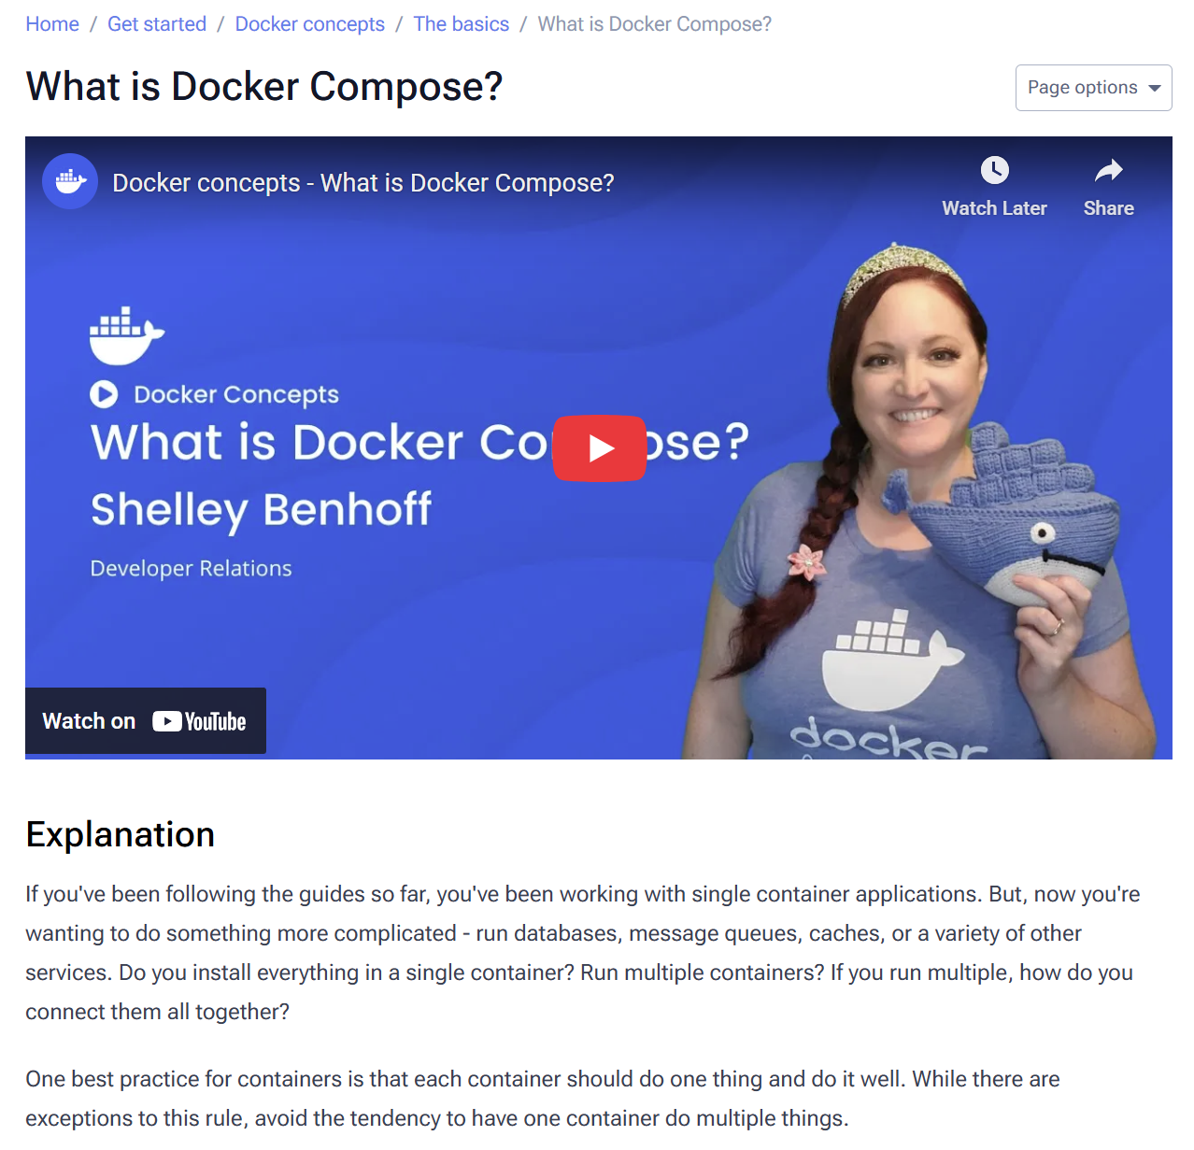

* The Multi-Container Problem: Real-world applications often require multiple services (e.g., databases, caches, APIs). Managing these with separate docker run commands becomes complex, involving networks and numerous flags.
* Core Best Practice: A container should do one thing and do it well. Avoid running multiple services in a single container.
* The Solution: Docker Compose
  + It allows you to define and manage multiple containers and their configurations in a single, declarative YAML file.
  + It simplifies setup; anyone with the file can start the entire application stack with one command (docker compose up).
  + It is declarative; running docker compose up again will intelligently apply any changes made to the configuration.
* Dockerfile vs. Compose File:
  + Dockerfile: A blueprint for *building* a single container image.
  + Compose File: A blueprint for *configuring and running* a multi-container application, which can reference Dockerfiles to build the needed images.

## 1.2 Process

Open a terminal and [clone this sample application](https://github.com/dockersamples/todo-list-app).

git clone https://github.com/dockersamples/todo-list-app

Navigate into the todo-list-app directory. Inside this directory, we'll find a file named compose.yaml.

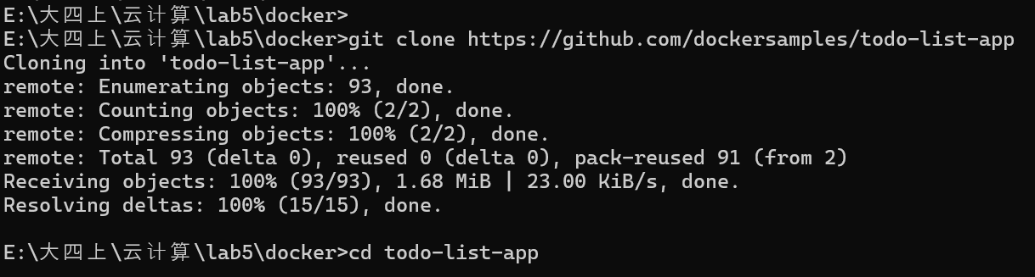

Use the [docker compose up](https://docs.docker.com/reference/cli/docker/compose/up/) command to start the application:

docker compose up -d –build

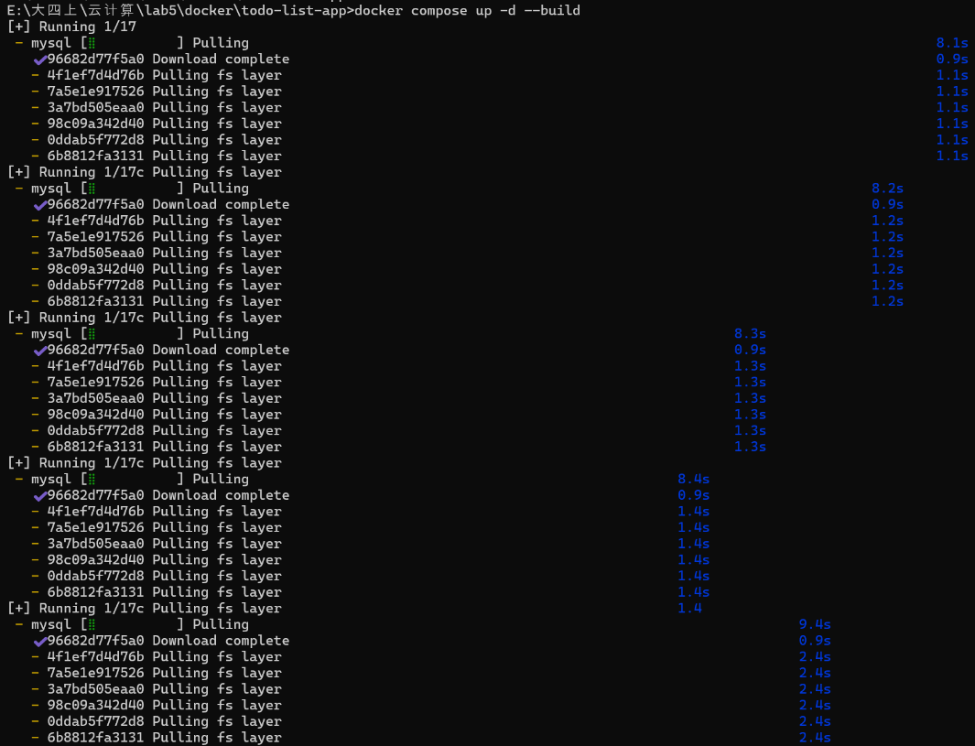

If we look at the Docker Desktop GUI, we can see the containers and dive deeper into their configuration.

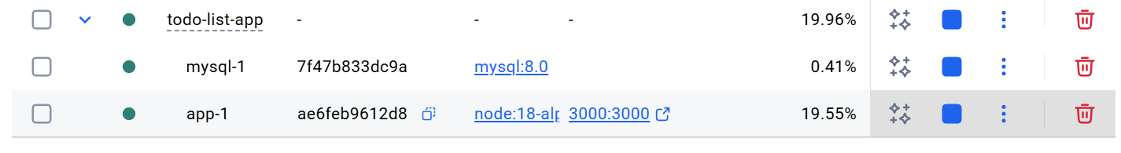

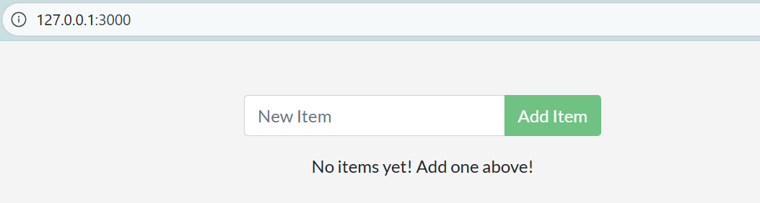

# 4.Publishing and exposing ports

## 1.1 Theory

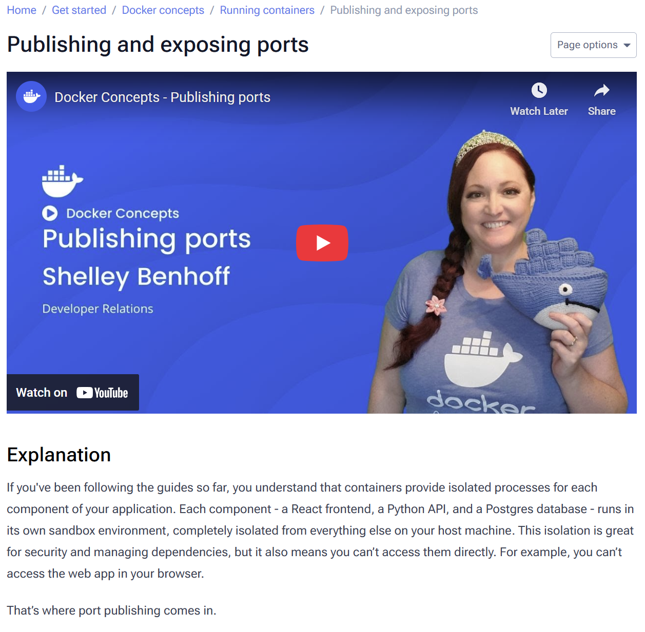

* The Problem: Container isolation means applications running inside them are not accessible from the host machine (e.g., a web app in a container can't be reached by a browser).
* The Solution: Port Publishing. This creates a network forwarding rule, allowing traffic to pass from the host machine into a container.
* How to Publish Ports:
  + Use the -p or --publish flag with the docker run command.
  + Syntax: -p HOST_PORT:CONTAINER_PORT
  + Example: docker run -d -p 8080:80 nginx forwards host port 8080 to the container's port 80.
* Key Considerations:
  + Published ports are accessible from *all* network interfaces by default, which is a security risk for sensitive services like databases.
* Publishing Variations:
  + Ephemeral Host Port: Use -p CONTAINER_PORT (e.g., -p 80) and Docker will automatically assign an available high-numbered host port.
  + Publish All Exposed Ports: Use the -P (uppercase) flag to automatically publish all ports declared with the EXPOSE instruction in the image's Dockerfile to ephemeral host ports. This is useful for avoiding port conflicts.

## 1.2 Process

Publishing a port provides the ability to break through a little bit of networking isolation by setting up a forwarding rule.

As an example, you can indicate that requests on your host’s port 8080 should be forwarded to the container’s port 80. Publishing ports happens during container creation using the -p (or --publish) flag with docker run. The syntax is:

docker run -d -p HOST_PORT:CONTAINER_PORT nginx

For example, to publish the container's port 80 to host port 8080:

docker run -d -p 8080:80 nginx

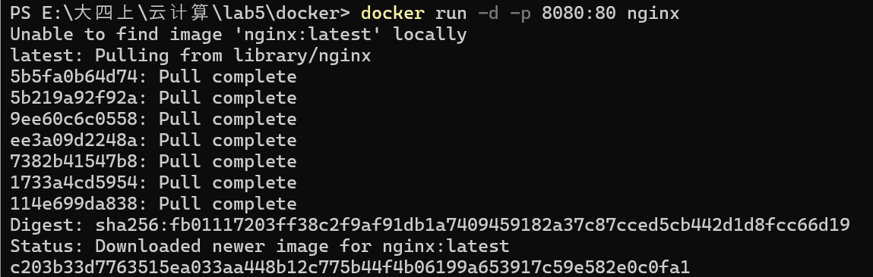

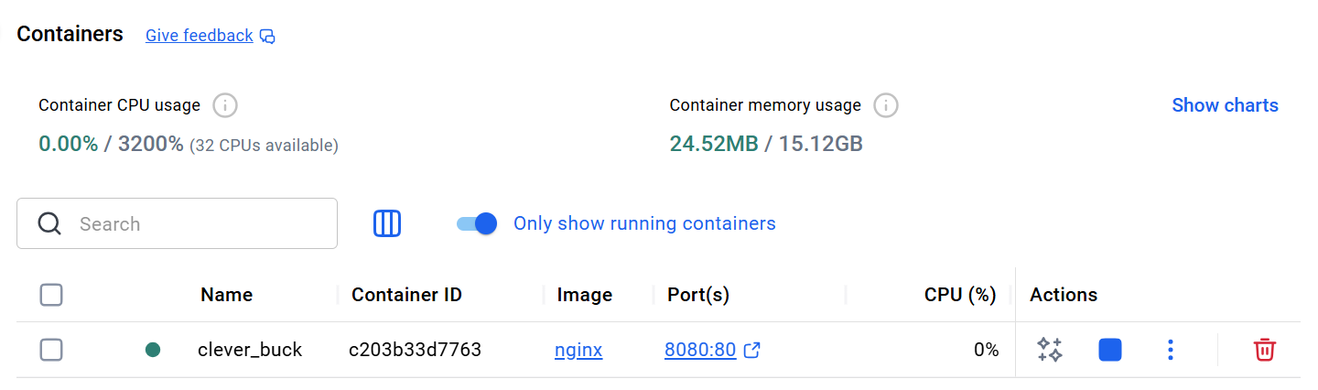

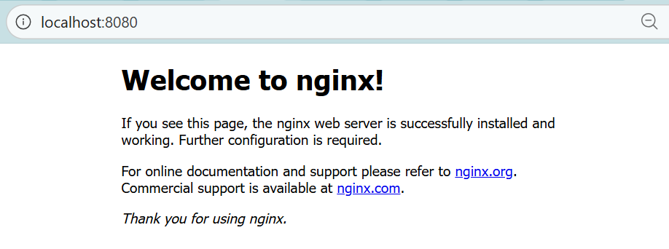

# 5.Overriding container defaults

## 1.1 Theory

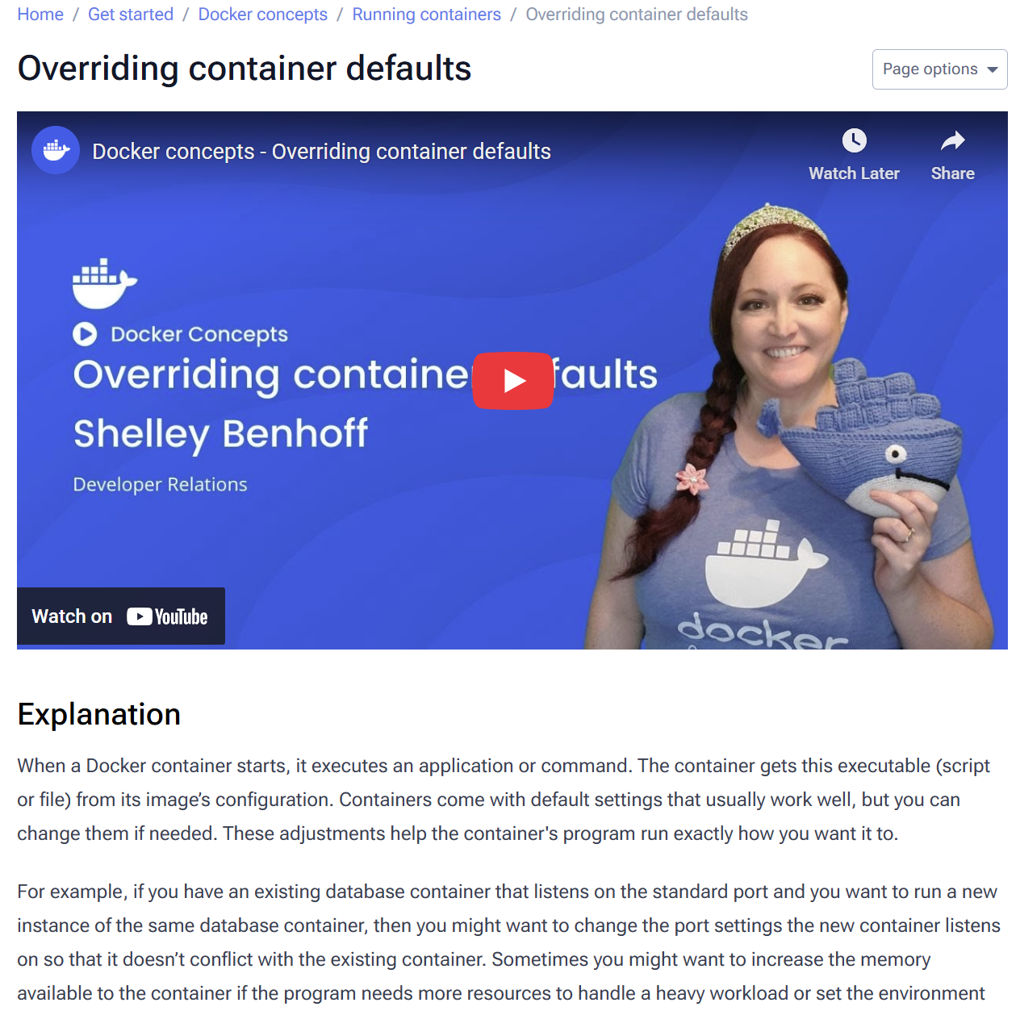

* Core Concept: A Docker container runs an application based on its image's default configuration. The docker run command is used to override these defaults and customize the container's behavior at startup.
* Key Customization Methods:
  + Network Ports: Use the -p flag (-p HOST_PORT:CONTAINER_PORT) to map container ports to host ports, preventing conflicts when running multiple instances (e.g., different databases for dev and test).
  + Environment Variables: Use the -e flag (-e VARIABLE=value) to pass configuration details to the application inside the container. For multiple variables, use an --env-file to point to a .env file.
  + Resource Limits: Use flags like --memory and --cpus to restrict a container's resource consumption, preventing it from overusing host system resources.
* Monitoring: Use the docker stats command to monitor the real-time resource usage (CPU, memory) of running containers, helping to verify and adjust resource limits as needed.
* Overall Purpose: These customizations allow you to tailor containerized applications to specific requirements, manage conflicts, control resource allocation, and ensure they run correctly in different environments.

## 1.2 Process

### 1. Run multiple instances of the Postgres database

Sometimes we might want to use separate database instances for development and testing purposes. Running these database instances on the same port might conflict.

We can use the -p option in docker run to map container ports to host ports, allowing you to run the multiple instances of the container without any conflict.

docker run -d -p HOST_PORT:CONTAINER_PORT postgres

Start a container using the [Postgres image](https://hub.docker.com/_/postgres) with the following command.This will start the Postgres database in the background, listening on the standard container port 5432 and mapped to port 5432 on the host machine.



Start a second Postgres container mapped to a different port.



This will start another Postgres container in the background, listening on the standard postgres port 5432 in the container, but mapped to port 5433 on the host machine. We override the host port just to ensure that this new container doesn't conflict with the existing running container.

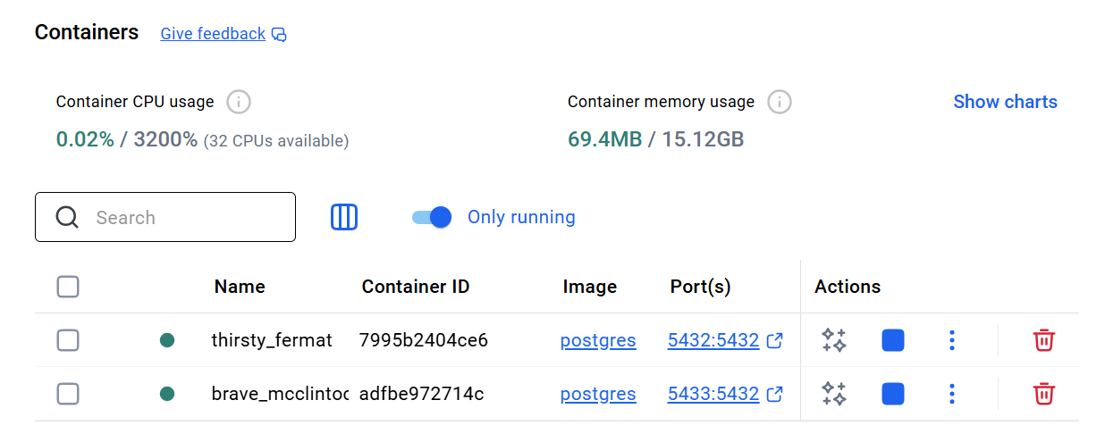

### 2. [Run Postgres container in a controlled network](https://docs.docker.com/get-started/docker-concepts/running-containers/overriding-container-defaults/#run-postgres-container-in-a-controlled-network)

By default, containers automatically connect to a special network called a bridge network when you run them. This bridge network acts like a virtual bridge, allowing containers on the same host to communicate with each other while keeping them isolated from the outside world and other hosts.

It's a convenient starting point for most container interactions. However, for specific scenarios, we might want more control over the network configuration.

Create a new custom network and verify the network. Connect Postgres to the custom network.

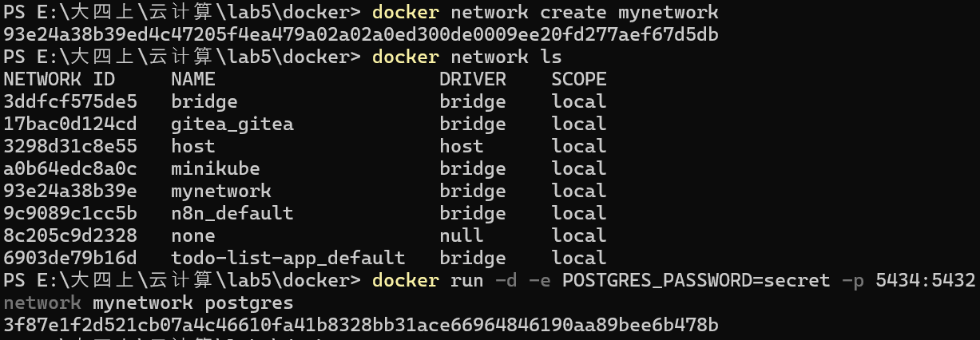

This will start Postgres container in the background, mapped to the host port 5434 and attached to the mynetwork network. You passed the --network parameter to override the container default by connecting the container to custom Docker network for better isolation and communication with other containers.

### 3. [Override the default CMD and ENTRYPOINT in Docker Compose](https://docs.docker.com/get-started/docker-concepts/running-containers/overriding-container-defaults/#override-the-default-cmd-and-entrypoint-in-docker-compose)

Create a compose.yml file with the following content:

services:

postgres:

image: postgres:18

entrypoint: ["docker-entrypoint.sh", "postgres"]

command: ["-h", "localhost", "-p", "5432"]

environment:

POSTGRES_PASSWORD: secret

The Compose file defines a service named postgres that uses the official Postgres image, sets an entrypoint script, and starts the container with password authentication.

Bring up the service by running the following command:

docker compose up -d

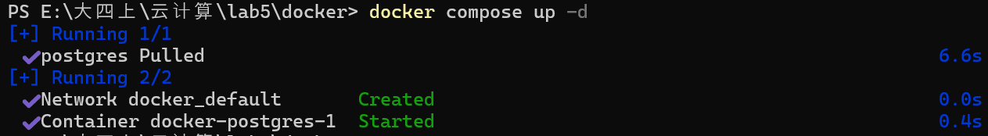

Verify the authentication with Docker Desktop Dashboard.

Open the Docker Desktop Dashboard, select the **Postgres** container and select **Exec** to enter into the container shell. We can type the following command to connect to the Postgres database:

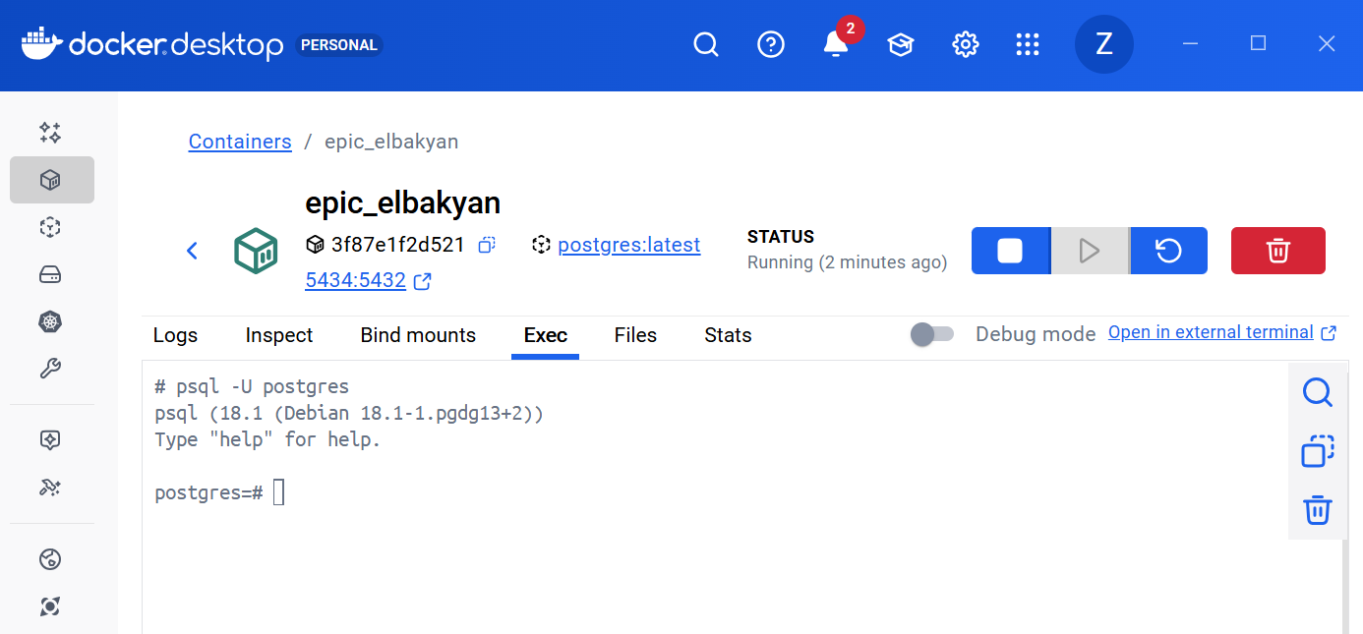

# 6. Persisting container data

## 1.1 Theory

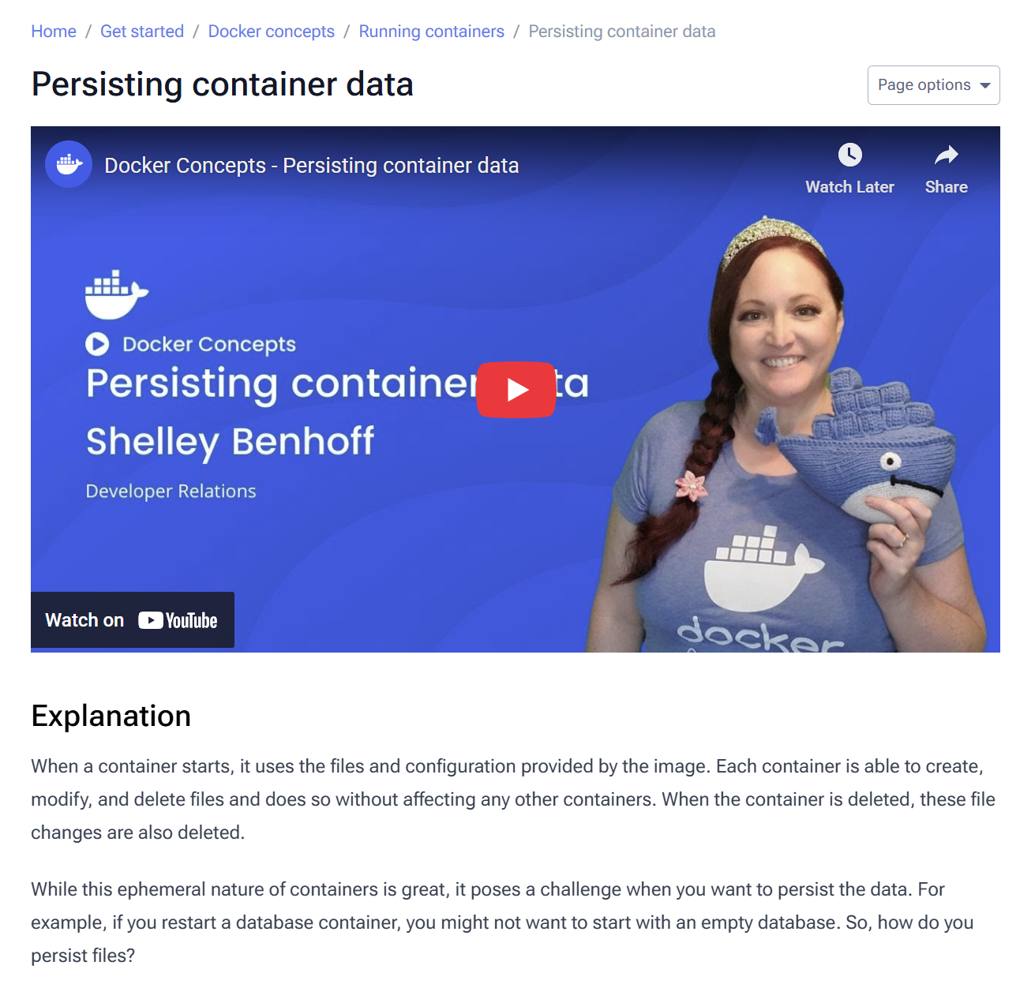

* The Problem of Ephemeral Containers:
  + Containers are ephemeral; any files they create or modify are deleted when the container itself is deleted.
  + This is a challenge for data that must persist, such as database files.
* The Solution: Container Volumes
  + Volumes are a storage mechanism for persisting data independently of a container's lifecycle.
  + They act like a link from a directory inside the container to storage outside the container.
* How Volumes Work:
  + A volume (e.g., log-data) can be created manually or automatically when a container starts.
  + It is mounted to a specific path inside the container (e.g., /logs).
  + Any data written to that path is saved in the volume.
  + If the container is deleted and a new one uses the same volume, the data remains accessible.
* Key Use Cases for Volumes:
  + Data Persistence: To retain critical data like application state or databases.
  + File Sharing: The same volume can be attached to multiple containers, enabling data sharing for log aggregation, data pipelines, etc.
* Volume Management:
  + Volumes have their own lifecycle and can be managed separately from containers.
  + Essential commands include:
    - docker volume ls (list volumes)
    - docker volume rm <volume-name> (remove a specific volume)
    - docker volume prune (remove all unused volumes).

## 1.2 Process

Start a container using the [Postgres image](https://hub.docker.com/_/postgres) with the following command:



This will start the database in the background, configure it with a password, and attach a volume to the directory PostgreSQL will persist the database files.

Connect to the database by using the following command:

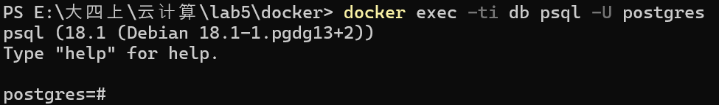

In the PostgreSQL command line, run the following to create a database table and insert two records:

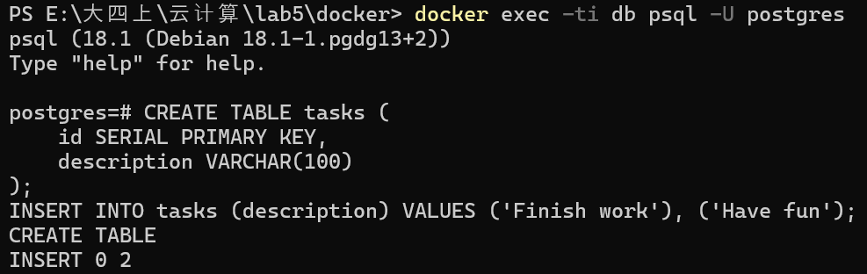

Verify the data is in the database by running the following in the PostgreSQL command line:

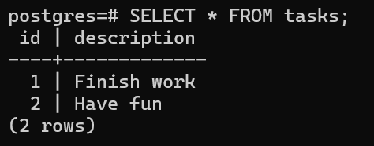

Stop and remove the database container. Remember that, even though the container has been deleted, the data is persisted in the postgres_data volume.

Start a new container by running the following command, attaching the same volume with the persisted data. Verify the database still has the records by running the following command:

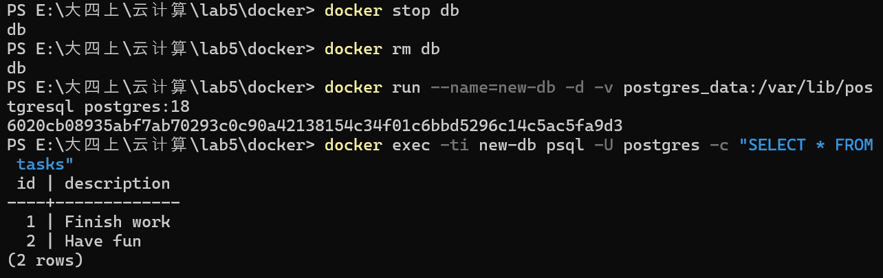

# 7. Sharing local files with containers

## 1.1 Theory

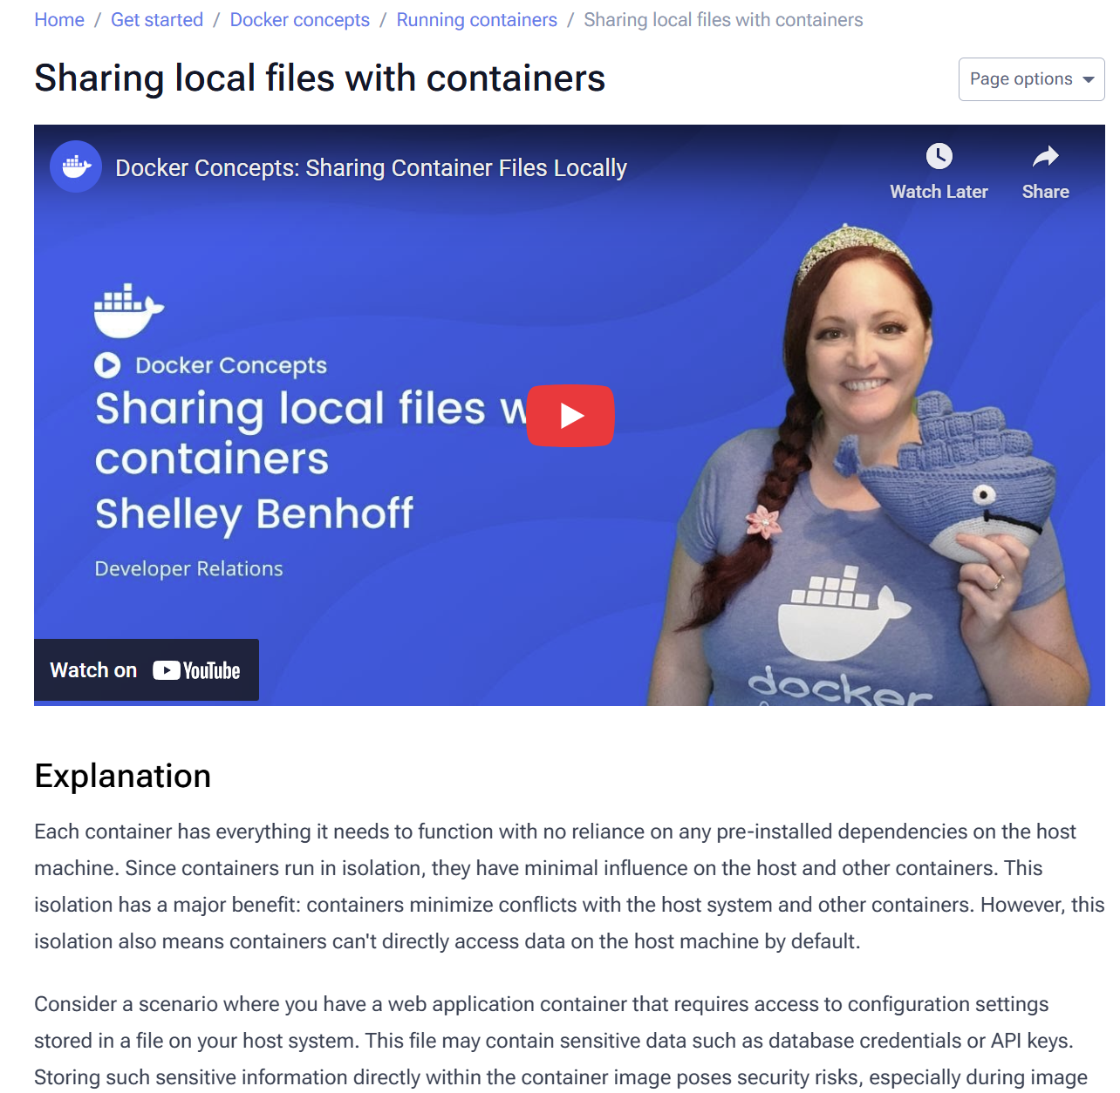

* Core Challenge: Container isolation prevents them from accessing host machine data by default, creating a need to share files (e.g., configuration, code) securely and persistently.
* Solution: Docker Storage Options
  + Volumes: The preferred mechanism for persisting data generated by a container (e.g., database files). Managed by Docker and independent of the host's directory structure.
  + Bind Mounts: Used to share specific host files or directories with a container. Ideal for development, as they provide a direct, real-time link for sharing code or config files.
* Implementation & Syntax:
  + Use the docker run command with either the -v (or --volume) flag or the --mount flag.
  + -v Flag: Simpler and automatically creates the host path if it doesn't exist.
  + --mount Flag: Recommended by Docker. Offers more explicit and granular control but will error if the host path does not exist.
* Critical Security & Control: File Permissions
  + Use :ro (read-only) or :rw (read-write) flags to control container access to host files.
  + Read-only (:ro) is safer, preventing a container from accidentally modifying or deleting host files.
* Performance Consideration:
  + For larger codebases, Synchronized File Shares can optimize bind mount performance by using synchronized filesystem caches, making file access faster and more efficient.

## 1.2 Process

### 1. [Run a container](https://docs.docker.com/get-started/docker-concepts/running-containers/sharing-local-files/#run-a-container)

Start a container using the [httpd](https://hub.docker.com/_/httpd) image with the following command:

docker run -d -p 8080:80 --name my_site httpd:2.4

This will start the httpd service in the background, and publish the webpage to port 8080 on the host.

Open the browser and access [http://localhost:8080](http://localhost:8080/) or use the curl command to verify if it's working fine or not.

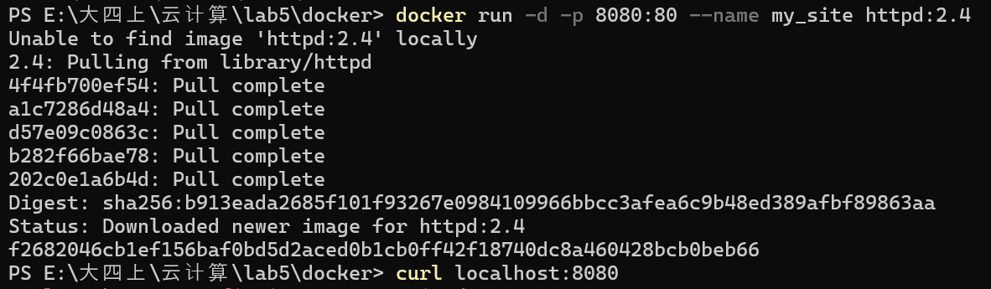



### 2. [Use a bind mount](https://docs.docker.com/get-started/docker-concepts/running-containers/sharing-local-files/#use-a-bind-mount)

Using a bind mount, we can map the configuration file on your host computer to a specific location within the container. In this example, we’ll change the look and feel of the webpage by using bind mount.

Delete the existing container by using the Docker Desktop Dashboard. Create a new directory called public_html on your host system.

Navigate into the newly created directory public_html and create a file called index.html with the following content.

Then, run the container.





With everything now up and running, we should be able to access the site via [http://localhost:8080](http://localhost:8080/) and find a new webpage that welcomes us with a friendly whale.

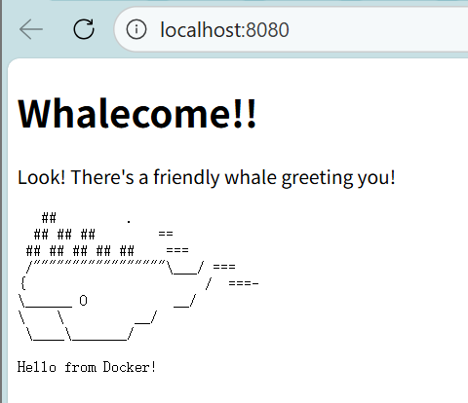

# 8. Multi-container applications

## 1.1 Theory

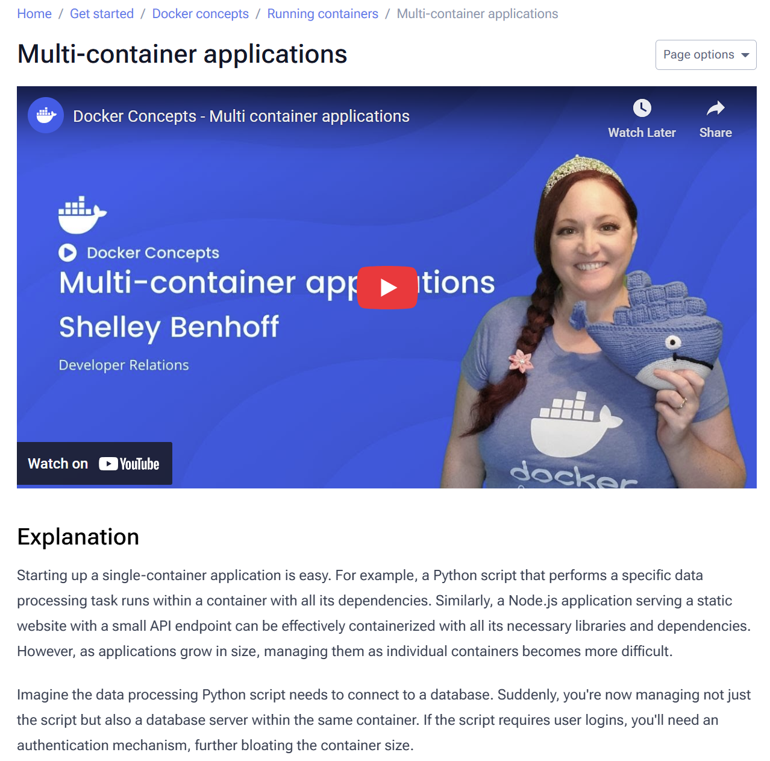

* The Limitation of Single Containers:
  + While easy for simple apps (e.g., a Python script, a Node.js website), managing a complex application as one container becomes difficult.
  + Following the best practice that "each container should do one thing well," a multi-component app (like one needing a database and authentication) should not be bundled into a single, bloated container.
* The Problem with docker run:
  + Manually running multiple docker run commands for a stack (frontend, backend, database) is error-prone and time-consuming.
  + Key challenges include:
    - Managing startup order and inter-container connections.
    - Difficulty scaling individual services.
    - Scattered and tedious configuration for data persistence and environment variables across different environments (dev, test, production).
* The Solution: Docker Compose
  + It defines the entire multi-container application in a single, centralized compose.yml YAML file.
  + This file specifies all configurations for containers, their dependencies, networks, and volumes.
* Key Benefits of Docker Compose:
  + Simplified Management: No need for multiple docker run commands; one file manages the entire stack.
  + Orchestration: Easily manages container startup order and network connections.
  + Efficient Scaling: Allows for easy scaling of individual services.
  + Centralized Configuration: Simplifies the management of persistent volumes and environment variables.
  + Promotes Modularity & Consistency: Ensures the application runs the same way across all environments.

## 1.2 Process

Use the following command in a terminal to clone the sample application repository. Navigate into the nginx-node-redis directory. Inside this directory, we'll find two sub-directories - nginx and web.

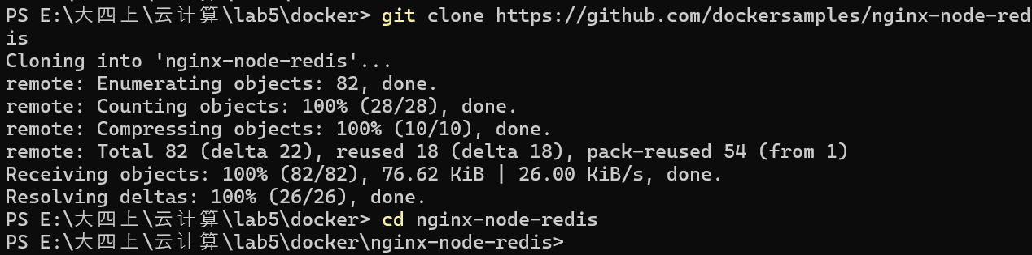

Navigate into the nginx directory to build the image by running the following command.

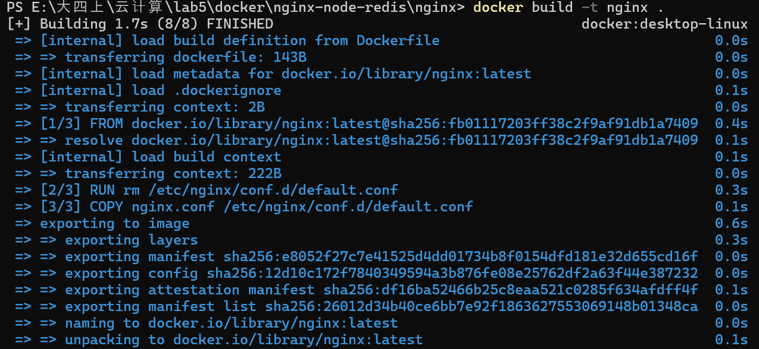

Navigate into the web directory and run the following command to build the first web image.

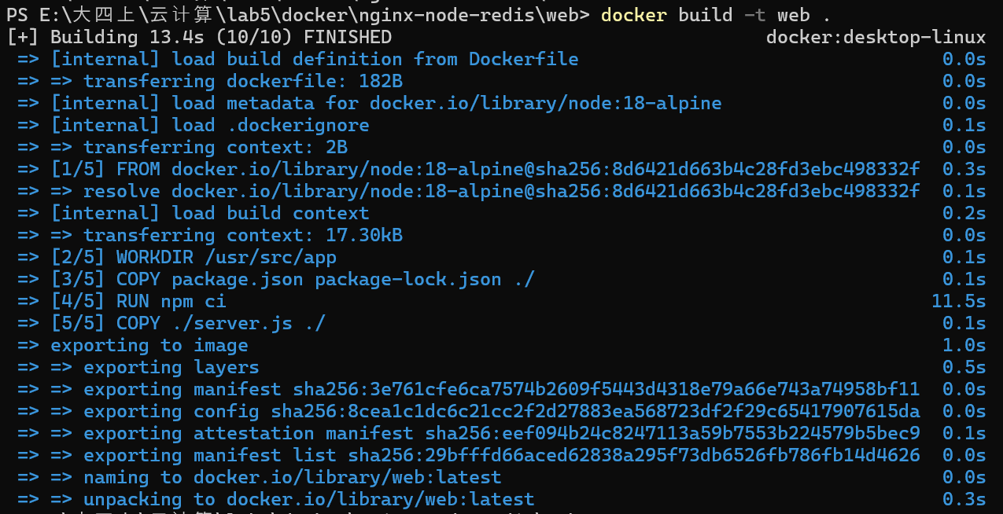

Before you can run a multi-container application, we need to create a network for them all to communicate through. We can do so using the docker network create command.



Start the Redis container by running the following command, which will attach it to the previously created network and create a network alias (useful for DNS lookups).

Start the first web container and the second web container by running the following command:

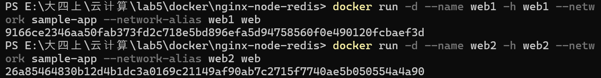

Start the Nginx container by running the following command:



If we look at the Docker Desktop Dashboard, we can see the containers and dive deeper into their configuration.

